AeriIQ — AI Smart Ventilation & Indoor Air-Quality System
Technical Report — components, wiring, code, installation and use
Prepared by Ibtisam Rafiq | 13 September 2026

1. Status
Item | Detail
Current status | Starting now — design, wiring and code base complete
Progress | 15%
Platform | Raspberry Pi 5 + Camera Module 3 + air-quality sensors

2. Problem statement
In the UAE, buildings remain closed for most of the year due to extreme temperatures and frequent dust storms, leading to poor indoor air quality and accumulation of pollutants such as CO₂ and particulate matter. Existing ventilation and HVAC systems operate on fixed settings without real-time monitoring or adaptive control, resulting in inefficient energy use and potential health risks for occupants. An intelligent system is needed that continuously monitors indoor air conditions and dynamically adjusts ventilation based on data-driven insights.

3. System overview
AeriIQ is an AI-based smart ventilation and indoor air-quality monitoring system for UAE environments. Sensors measure CO₂, temperature, humidity and particulate matter, a camera counts occupants, and a lightweight machine-learning model predicts CO₂ fifteen minutes ahead so that ventilation starts before air quality degrades. The controller drives exhaust and fresh-air fans and a window/damper actuator, keeps the window closed when outdoor dust or heat is high, and enforces minimum run-times to save energy. Readings and decisions are logged and charted on a dashboard, demonstrating how AI and IoT combine into an energy-efficient solution supporting UAE sustainability goals.

4. Components (bill of materials)
Component | Qty | Purpose / notes
Raspberry Pi 5 8 GB + PSU + cooler + SD | 1 | Controller, inference, dashboard
Camera Module 3 + cable | 1 | Occupancy counting
Sensirion SCD41 | 1 | NDIR CO₂/T/RH, I²C 0x62
Plantower PMS5003 + adapter | 1 | PM1/2.5/10, UART
BME280 | 1 | Pressure, backup T/RH
SSD1306 0.96" OLED | 1 | Live readings
2-channel relay module | 1 | Exhaust + intake fans
12 V fans (demo) or 220 V fans | 2
MG996R servo + 5 V 3 A supply | 1 | Window/damper
Buzzer + red LED | 1 | CO₂ alarm
Ventilated enclosure | 1

5. Wiring
Component pins | Board pins | Notes
Camera ribbon | CAM/DISP 0 | CSI
SCD41 VDD / GND / SDA / SCL | pins 1 / 6 / 3 / 5 | I²C 0x62
PMS5003 VCC / GND / TX | pins 2 / 9 / 10 | UART 9600
BME280 VCC / GND / SDA / SCL | pins 17 / 14 / 3 / 5 | I²C 0x76
OLED VCC / GND / SDA / SCL | pins 1 / 20 / 3 / 5 | I²C 0x3C
Relay VCC / GND / IN1 / IN2 | pins 4 / 25 / 11 / 13 | GPIO17 exhaust, GPIO27 intake
Servo signal / GND (VCC external) | pins 12 / 30 | GPIO18 PWM
Buzzer + / LED + / − | pins 15 / 16 / 34 | GPIO22, GPIO23
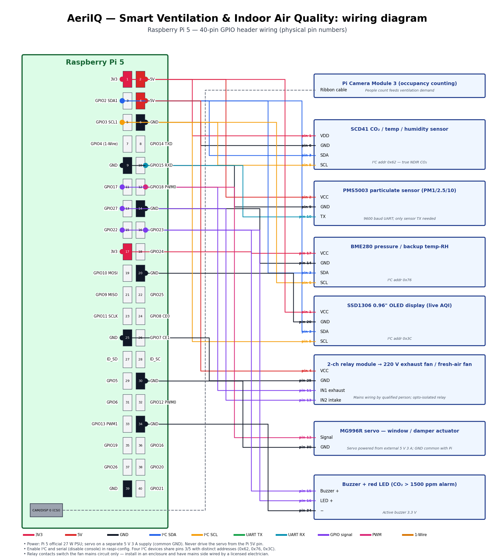
Figure 1 — aeriiq_wiring_diagram.png

6. Software structure
code/aeriiq/main.py read → count → predict → decide → actuate → log
code/aeriiq/sensors/ scd41.py, pms5003.py, bme280.py
code/aeriiq/vision/occupancy.py YOLOv8n person counting
code/aeriiq/ml/ features.py, train.py (GradientBoosting), predictor.py (15-min forecast + physics fallback)
code/aeriiq/control/ policy.py (decision rules), actuators.py (relays, servo, OLED, buzzer)
code/aeriiq/dashboard/ server.py, templates, static (Chart.js)
code/config/settings.yaml, code/models/, code/scripts/, code/systemd/aeriiq.service
code/tests/test_policy.py (4 tests passing)

7. How it works
- Every 30 s the SCD41, PMS5003 and BME280 are read; every 4th sample the camera counts people.
- The predictor estimates CO₂ 15 minutes ahead (trained model, or a physics fallback of ~8 ppm per person per minute until a model exists).
- Policy: ≥ 1500 ppm → exhaust + intake + window + alarm; ≥ 1000 ppm or forecast ≥ 1500 → fans pre-emptively; PM2.5 ≥ 35 keeps the window closed; outdoor heat keeps the window closed.
- Fans stay on at least 5 minutes once started (anti-chatter, energy).
- Actuators are set, the OLED shows live values, the row is logged and the dashboard charts CO₂ against forecast.
- After a week, export_training_data.py + train.py produce the forecasting model.

8. Installation
bash code/scripts/setup_pi.sh # apt, I²C/UART, venv, requirements; i2cdetect shows 0x3C, 0x62, 0x76
sudo cp code/systemd/aeriiq.service /etc/systemd/system && sudo systemctl enable --now aeriiq
# after one week of data:
python code/scripts/export_training_data.py && python -m aeriiq.ml.train

9. How to use
- Open http://<pi-ip>:8080 for live values, the ventilation reason and the CO₂/forecast chart.
- The OLED at the unit shows CO₂, PM2.5, temperature, RH, occupants and which actuators are on.
- Thresholds, pins and the minimum fan run-time are in config/settings.yaml.

10. How to connect
- Four I²C devices share pins 3/5 with distinct addresses; PMS5003 TX → Pi RX (pin 10) only.
- Servo on an external 5 V 3 A supply with common ground.
- Relay contacts switch the fan circuit; mains fans in an enclosure wired by a licensed electrician.

11. Acceptance tests
- CO₂ within ±50 ppm of a reference meter
- Fans start within one sample of crossing 1000 ppm
- Forecast MAE < 60 ppm
- Window closed when PM2.5 > 35 µg/m³
- Fan run-time reduced vs fixed schedule with CO₂ < 1000 ppm 95 % of occupied time

12. Next steps
- Order hardware; enable I²C/UART; verify the three I²C addresses.
- Bring up each sensor and the OLED; log to SQLite; verify the dashboard.
- Add occupancy counting; wire the 12 V fans and servo; confirm the policy tests pass on real data.
- Collect one week of classroom data; train the forecast model; evaluate MAE.
- Run a 3-day energy comparison against a fixed schedule; write the final report.

13. Handover items
- Design pack, wiring diagram, code base and tests
- No hardware purchased yet

Prepared by Ibtisam Rafiq, 13 September 2026.

